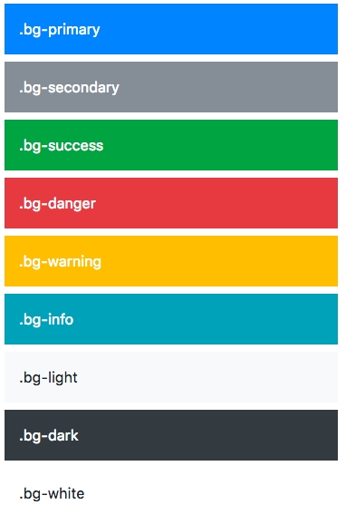

Background color utility classes: .bg-(light, dark primary, secondary, transparent, white, warning, success, info, danger)



Border utility class lets you add/remove borders on a side or change a border color. .border-(light, dark primary, secondary, transparent, white, warning, success, info, danger, 0, top-0, right-0, bottom-0, left-0, top, right, bottom, left)

**Button Outline**

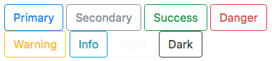

A button variation to have outlined buttons instead of a solid background. .btn-outline-(light, dark primary, secondary, transparent, white, warning, success, info, danger)

**Radius/Image Rounded Classes**

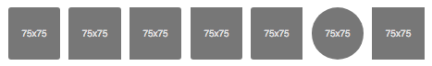

These classes add a border radius so you could use this on other elements that you would like a radius applied. You can also add .rounded-sm or .rounded-lg to increase the size of the radius. We can use rounded-0 to remove the applied border radius.

**Bootstrap Typography**

